Harvard Program in Refugee Trauma (HPRT) Screening App

Team Unmellow Yellow - Azmina Karukappadath, Scott Bettigole, and Anthony Ong

**Background**

As of 2017, we are looking at a record amount of displacement from homes in the world. According to United Nations Refugee Agency, UNHCR, 65.6 million people are currently living as refugees [1]. More than 50% of refugees are under the age of 18, although children only make up 31% of the world’s population; most of these children are also fleeing on their own [1].

Individuals in these refugee camps have often gone through traumatic events - oftentimes even experienced torture to be made submissive by those in power. Because of this, treatment for these refugees often include psychiatric as well as physical health care. To help alleviate the growing need for intensive medical care for these individuals, the Harvard Program in Refugee Trauma (HPRT) was founded in 1981.

One aspect of care that was developed by this program is the 11 Point Questionnaire, a survey of various questions that span 11 main topics that allow doctors to adequately assess where a patient is in terms of psychological and physical trauma so that they can administer the care that the individual needs. This questionnaire is answered by an individual whenever they enter a camp - this allows doctors to have some sort of record of everyone who enters the camp, and have a rough idea of what care they may need.

Although the HPRT has been able to make an incredible impact in the quality of care in these refugee camps, they are often plagued by limitations - one major limitation is the fact that all records are kept on paper. By pushing the medical information being stored from paper to electronic record-keeping, these doctors could work more efficiently and effectively to provide their patients with the care they need. Additionally, refugees that have undergone extensive trauma would no longer be required to relive their trauma every time they enter a new camp if the 11-point questionnaire answers have been stored securely.

The electronic medical record system was an essential step in advancing the level of care that doctors could provide their patients in many developed regions. The movement of patient information to computers allowed doctors to consolidate all of a patient’s medical history for easier access. Clinicians can then use the EMR system to find correlations between symptoms [5], view family histories to consider the patient’s predispositions to various illnesses and conditions [5], take allergies and pre-existing conditions of a patient into consideration to prescribe medication and treatment more safely [5], and help keep track of resources to avoid  
drug shortages [2]. Electronic medical records make it so that accessing a patient’s history is simple and quick; they eliminate the need to sift through countless paper records and the concern of lost or damaged records [2, 3, 4, 5].

However, most EMR systems have been developed for medical settings that have constant access to internet and powerful computers. Various difficulties that have arisen when EMR systems have been introduced into developing regions include: unreliability through depending on internet connection that isn’t always available, inaccessibility with few devices with the software installed or not enough devices for all the doctors to use, inflexibility because the system does not allow doctors to record what they want to record or lacks the ability to be expanded upon, and difficulty of navigation requiring clinicians to be computer literate or requiring extensive training to implement the system [2, 3, 4, 5].

By using an electronic medical record system, the doctors of the HPRT would be better able to provide quality care to their patients. In addition, by tracking movement of individuals between camps using this software, we hope to include features that reunite separated family members through facial recognition software. Another reach goal we hope to take steps towards is geared towards battling the practice of human trafficking. Women and children are often promised an escape from certain refugee camps, only to be sold to traffickers. These groups often travel from camp to camp on their way out of the country. By electronically storing all those who enter different refugee camps, we would be able to track these movements and have a better idea of where these individuals are being brought to; this would be one important step towards alleviating this issue. By implemented a secure and tolerant electronic medical record system, we hope to help provide medical care to those who need it most; over time, we also hope to also achieve these reach goals.

**General Approach**

We are working with Dr. Richard F. Mollica and his team of doctors from the Harvard program in Refugee Trauma. We are also working with Professor Karen Panetta, Dean of Graduate Education at Tufts University. This project was started last year by a group of students who also worked with Dr. Mollica and Prof. Panetta. They were able to build an app that allowed doctors to record patients’ answers to the 11-point questionnaire and gave an assessment score from their answers. Answers to the questionnaire were saved as a PDF and emailed to any doctor. We are continuing this project and making improvements to it.

Instead of using PDFs, we want to create a database that can store patient information more compactly. Every doctor can download the app on their phones. They can download patient information to their phones from this database so even when an internet connection is not available, doctors can continue working. Patients who have already visited a doctor can have their information pulled up. This way patients won’t have to re-answer questions from the 11-point questionnaire or about general health as often. When internet connection is available, the medical information will be uploaded to a server. In this way, doctors will be able to retrieve, record, and update patient information quickly and provide better patient care overall.

**Goals**

Base Goals: Build an electronic medical record system that:

* Does not rely on constant internet access
* Complies with HIPAA laws (secure)
* Does not lose any data (persistent)
* Is inexpensive

Reach Goals: Add features such that:

* Patients and doctors are able to be authenticated through fingerprinting and facial recognition software
* Be able to store family information and use records to reunite families that have been separated

**Non-Goals**

We are not trying to:

* Change the way doctors provide care - only provide doctors a better system to store and retrieve information so they can be more effective in their work
* Stop human trafficking (this is only a step in the right direction)

**Network Architecture**

Our overall architecture will treat each camp to be like a node in a network of all the refugee camps in the system. A Raspberry Pi will be installed in every camp to act as a middle-man between the global database of refugee health data we will store on Heroku and the actual doctors in each particular camp. The Raspberry Pi should be located in an optimal location for satellite internet connectivity to ensure it is connected to the internet as much of the time as possible. The Raspberry Pi will receive information through two ports, one of which is used to communicate with the outside internet, and the other of which is used to communicate through a wifi connection with the phones of doctors in the field (see Figure 1). Every doctor will have our app, which contains the software necessary appropriately to help doctors complete the 11-point questionnaire, enter patient information, and interact with the database appropriately.

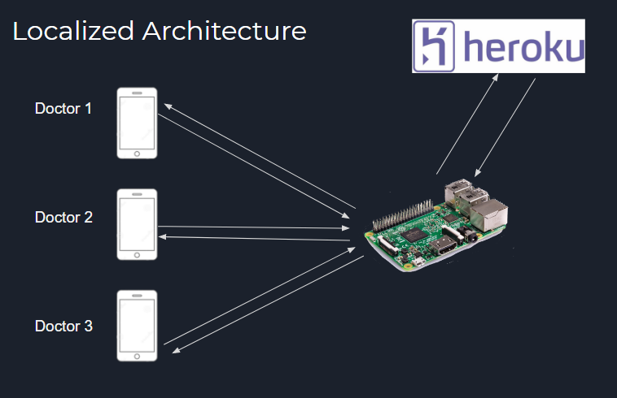

Figure 1. Local Architecture - Within Each Camp

Doctors should have access to not only medical health records regarding patients in their own camp, but also medical records from patients in surrounding camps. This will help doctors be able to retrieve medical information on patients that have recently moved from one camp to another. In a second application, imagine a scenario where a mother and her son have been separated. By maintaining the information on patients from nearby camps, the mother would be able to search for children around her son’s age, look at pictures of all children that match her search, and hopefully find her son. To functionally let doctors be able to query their local area of camps, the Raspberry Pi in each camp will maintain database information from patients in its own camp, as well as the database information of camps located within a certain geographical radius of that camp.

When a doctor queries the database, the doctor uses our app to send the query to the local Raspberry Pi. The Raspberry Pi receives the query, and searches the local area database it stores for the requested information. If it has the information, it sends that information back to the doctor. If it does not have the information requested, the Raspberry Pi sends a query to the complete database stored on Heroku, and returns the respective data or otherwise lets the doctor know the entry was not found.

When a doctor updates the database by either modifying an existing entry or adding a new entry, it will send the query to the Raspberry Pi, and the Raspberry Pi will update its local storage of the database accordingly. The Raspberry Pi will then send the update to Heroku to update the global database. Every Raspberry Pi will need to periodically query the remote database to properly maintain its local version of data related to the local area network of camps (see Figure 2).

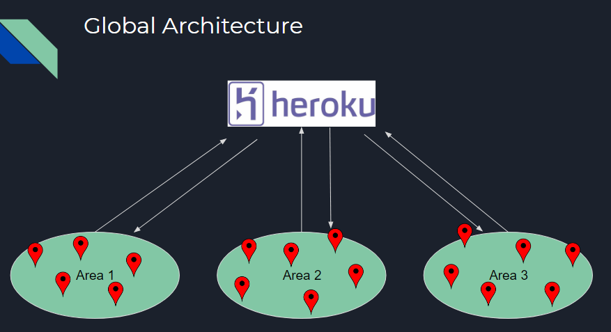

Figure 2. Global Architecture - Between Camps

**Privacy and Accessibility**

As we develop this application and the way that the data is stored, we must keep in mind security of information. We hope to create this app in a way that it can comply with HIPAA regulations. The Health Insurance Portability and Accountability Act (HIPAA) is a United States legislation that was instituted in 1996 to safeguard medical information of citizens. By it, doctors are not able to disclose medical information in a manner which would allow the identity of the patient to be revealed.

Although we would like to comply with this regulations, we are not sure if they are mandated since the doctors will be operating outside of the United States with non-American citizens. This is a question that we would like to ask the doctors directly, so that we can tailor the methods of data storage to their needs.

However, we have found that American laws concerning medical information are among the most strict; for this reason, we will comply with HIPAA regulations in hopes of complying with whatever laws may be in place in other countries.

**Access and Authentication Methods**

As secure access of patient information is of utmost importance, we need to make sure authentication to the system is as difficult to penetrate as possible. We want to incorporate two-factor authentication (at least) through a combination of random numerical identification, fingerprint scan, and facial recognition. We will start with implementing a random numerical identification as it is the simplest to embed into our system, but will then proceed with fingerprint identification, and finally we will hopefully integrate facial recognition, should be at a stage to do so before May. A doctor has access to the entire database, and so the system needs to be positive the doctor is definitely the one performing the query or database update. Doctors will need to re-authenticate themselves to the system every 30 minutes, or after 5 minutes of inactivity. Patients will equivalently need to authenticate themselves before gaining access to their own medical record information.

**Data Storage**

Our database will consist of rows and columns where each row represents and holds information for a single patient (see Figure 3). Each column represents a specific piece of information: names; Identification methods (ID, fingerprints); patients’ answers to the 11-point questionnaire; assessment scores; separate columns for basic health information; names of relatives; and recent appointments (time and location). This database will not only allow doctors to pull up a patient’s information, but it can also allow doctors to query the database so that they can easily assess the demographics of their patients. For example, suppose a group of patients came from another camp were mistreated there. Upon reassessment of these patients, doctors find many of them scored low on their 11-point questionnaires. A doctor can query the database for patients with scores below a certain threshold and then query that subset of data further for locations of their previous appointments. Hopefully, with this information actions can be taken to improve conditions at those camps found through the query. This is a small example of the power our database can provide to these doctors.

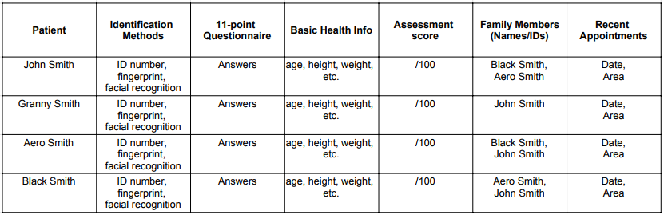

Figure 3. Database - Tabular representation of patient information

**References**

1. Beaubien, J. (2017, June 20). 5 Surprising Facts About The Refugee Crisis. Retrieved December 21, 2017, from https://www.npr.org/sections/goatsandsoda/2017/06/20/533634405/five-surprising-facts-about-the-refugee-crisis
2. Fraser, H., Biondich, P., Moodley, D., Choi, S., Mamlin, B., & Szolovits, P. (2005). Implementing electronic medical record systems in developing countries. Journal of Innovation in Health Informatics, 13(2), 83-95.
3. Kahouei, M., Zadeh, J. M., & Roghani, P. S. (2015). The evaluation of the compatibility of electronic patient record (EPR) system with nurses’ management needs in a developing country. International journal of medical informatics, 84(4), 263-270.
4. Ohuabunwa, E. C., Sun, J., Jubanyik, K. J., & Wallis, L. A. (2016). Electronic Medical Records in low to middle income countries: the case of Khayelitsha Hospital, South Africa. African Journal of Emergency Medicine, 6(1), 38-43.
5. Sikhondze, N. C., & Erasmus, L. Electronic Medical Records: A Developing and Developed Country Analysis.